**Using Secrets Manager to Authenticate with an RDS Database Using Lambda**

**Hands-on Lab**

AWS Secrets Manager helps you protect secrets needed to access your applications, services, and IT resources. The service enables you to easily rotate, manage, and retrieve database credentials, API keys, and other secrets throughout their lifecycle. In this lab, we connect to a MySQL RDS database from an AWS Lambda function using a username and password, and then we hand over credential management to the AWS Secrets Manager service. We then use the Secrets Manager API to connect to the database instead of hard-coding credentials in our Lambda function. By the end of this lab, you will understand how to store a secret in AWS Secrets Manager and access it from a Lambda function.

**Objectives**

* Create a Lambda Function
* Create the MySQL Layer, and Copy Your Code to the Lambda Function
* Create a Secret in Secrets Manager
* Test Connectivity from Lambda to RDS Using Credentials from AWS Secrets Manager
* Create Table in the RDS Database Using Lambda to Check Connectivity
* Modify the Lambda IAM Role

**Architecture**

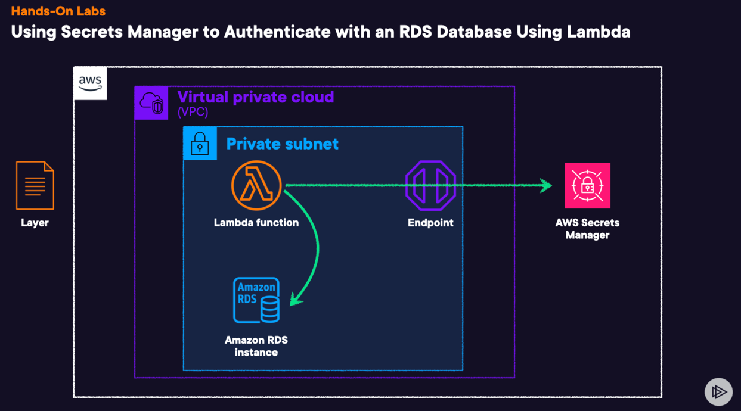

How to configure lambda to authenticate without needed to hardcode the credentials , your VPC is also mandated, you need to find a way to rotate the passwords

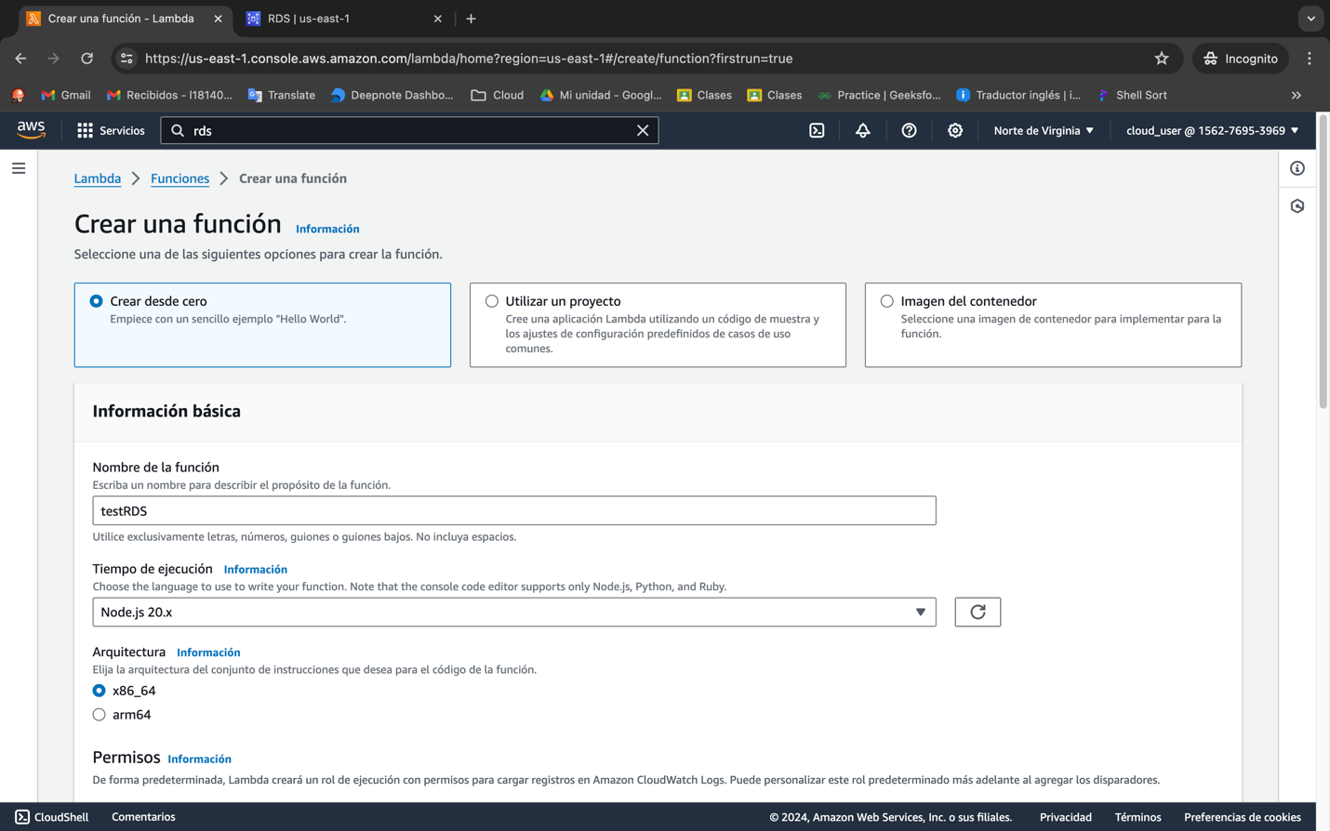

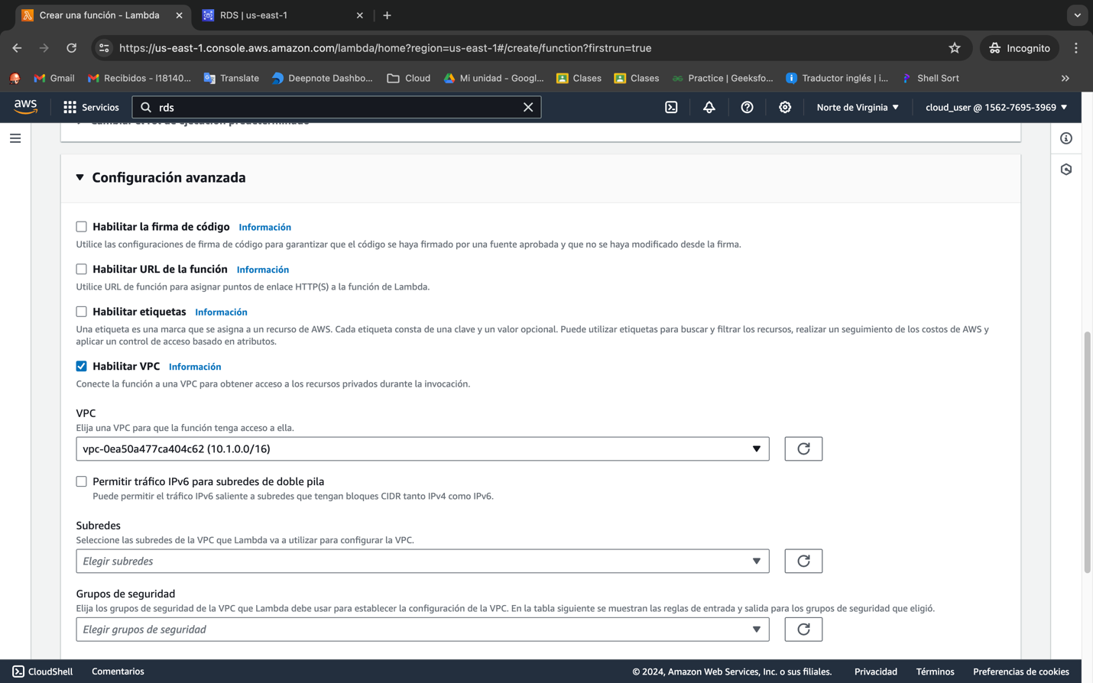

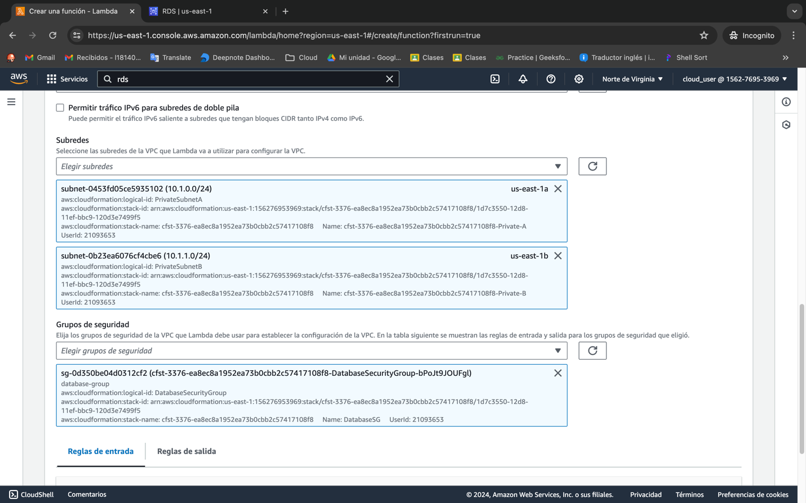

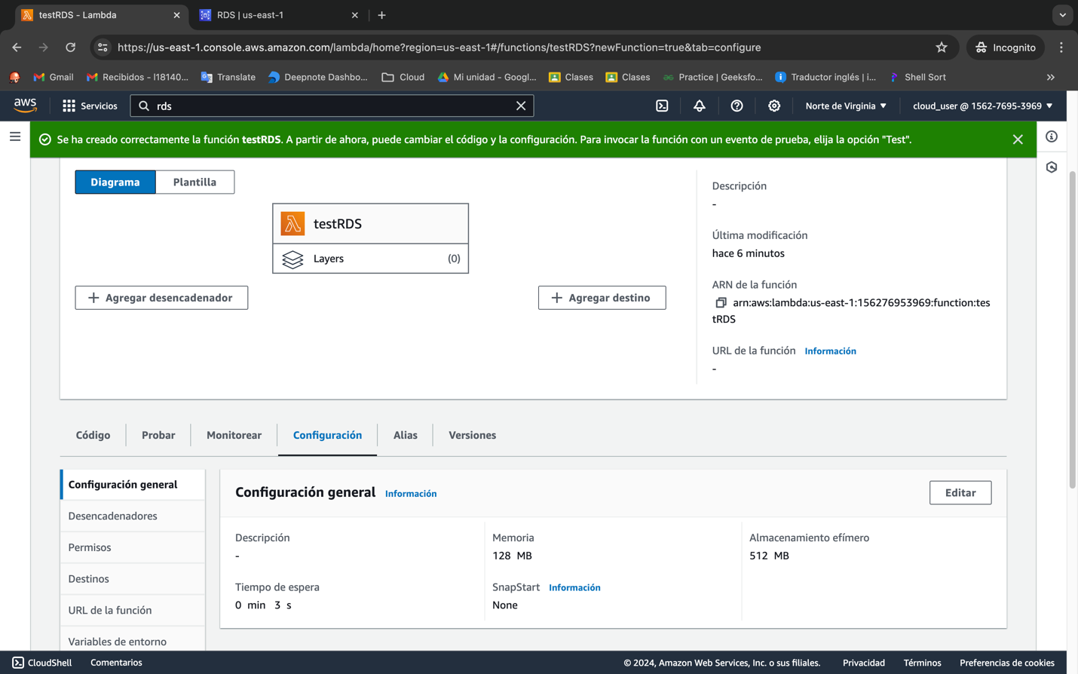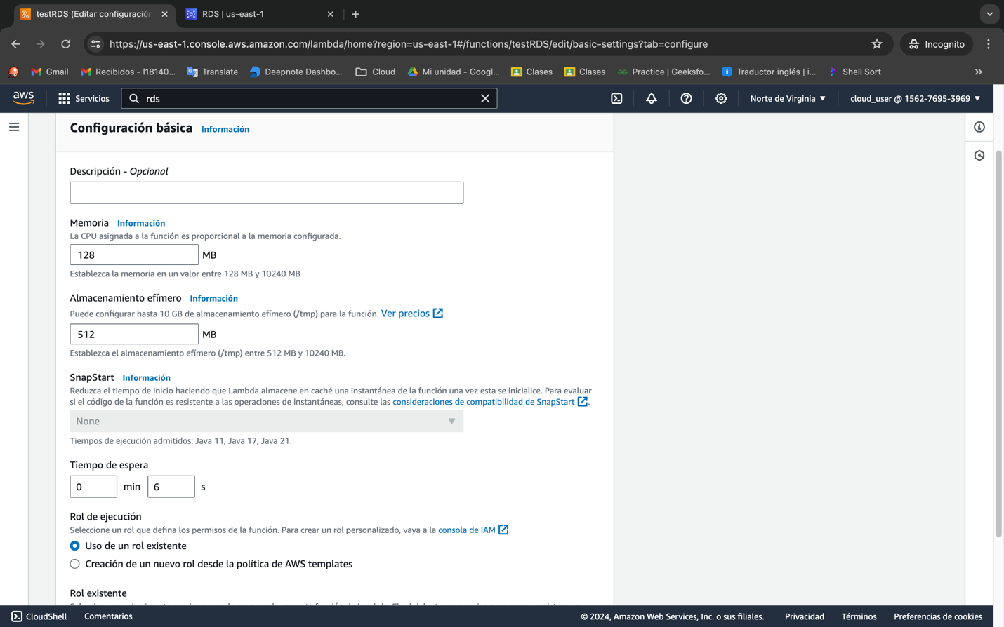

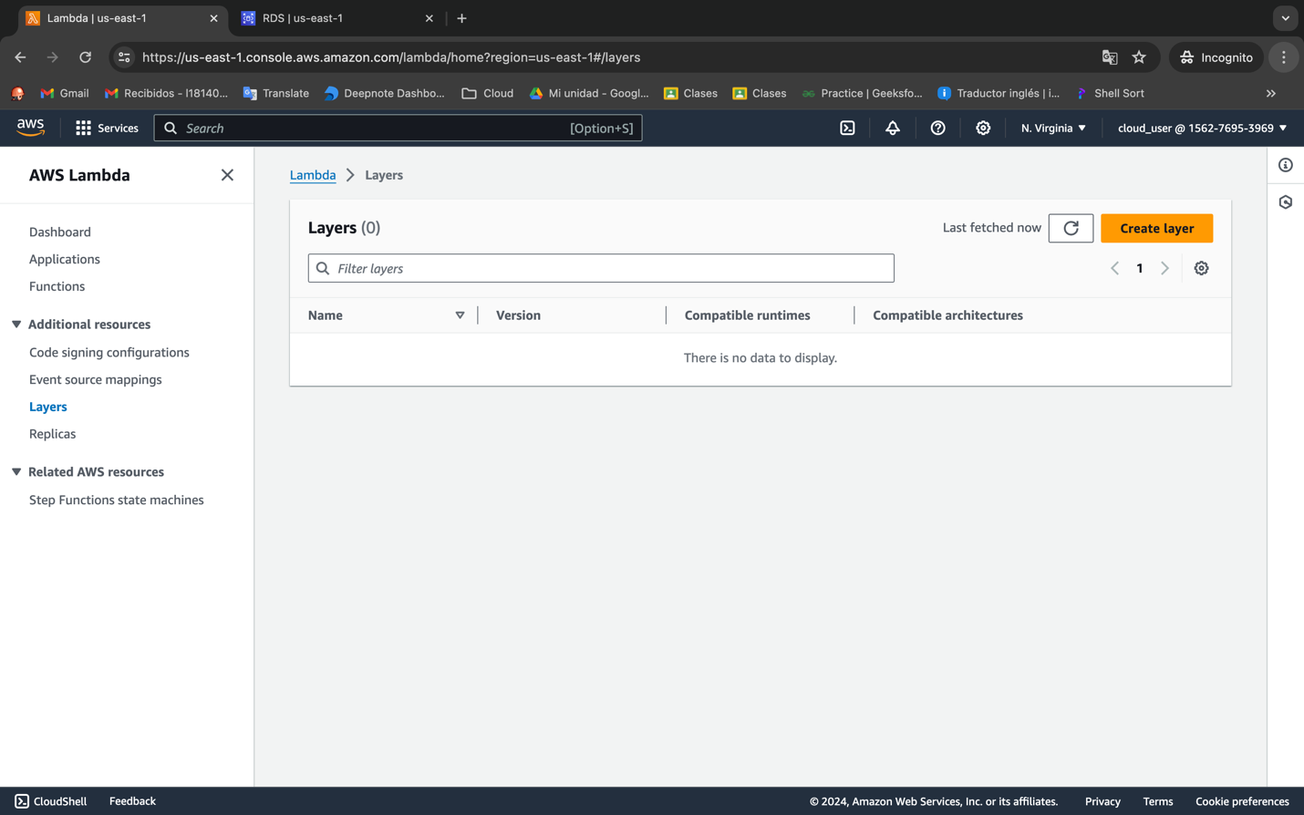

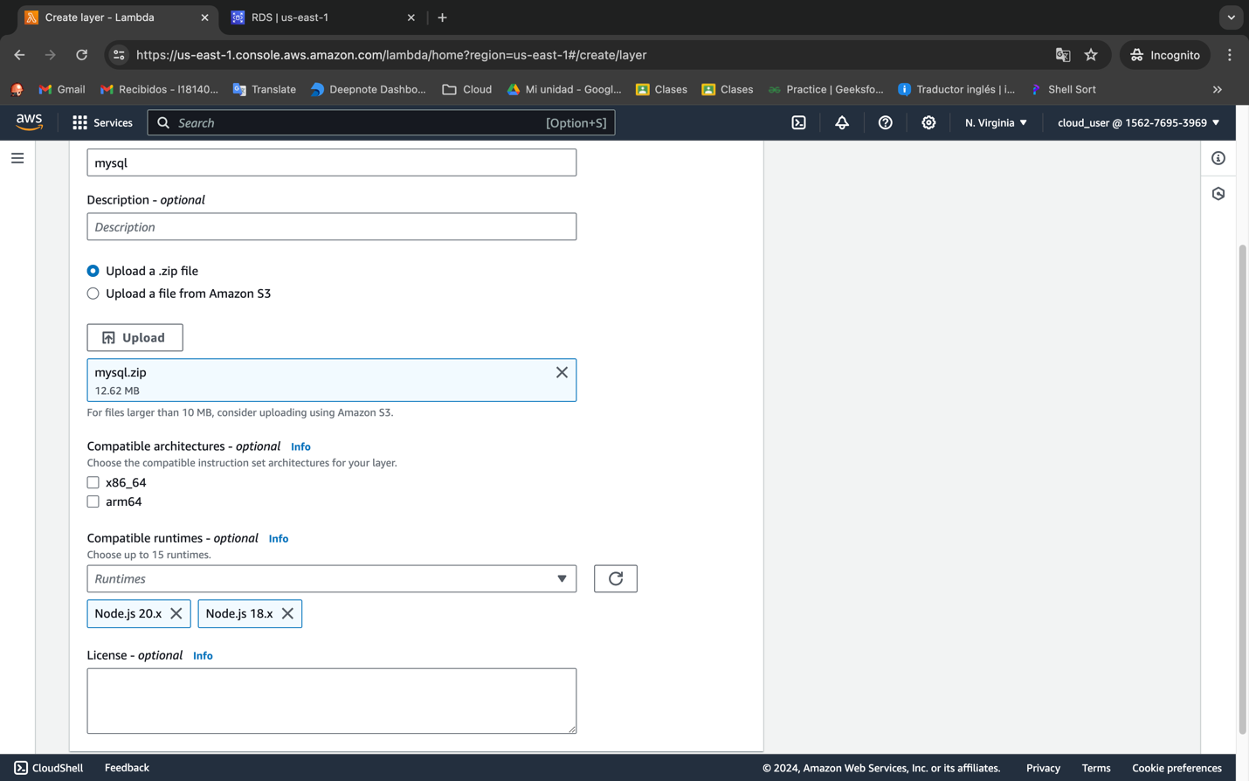

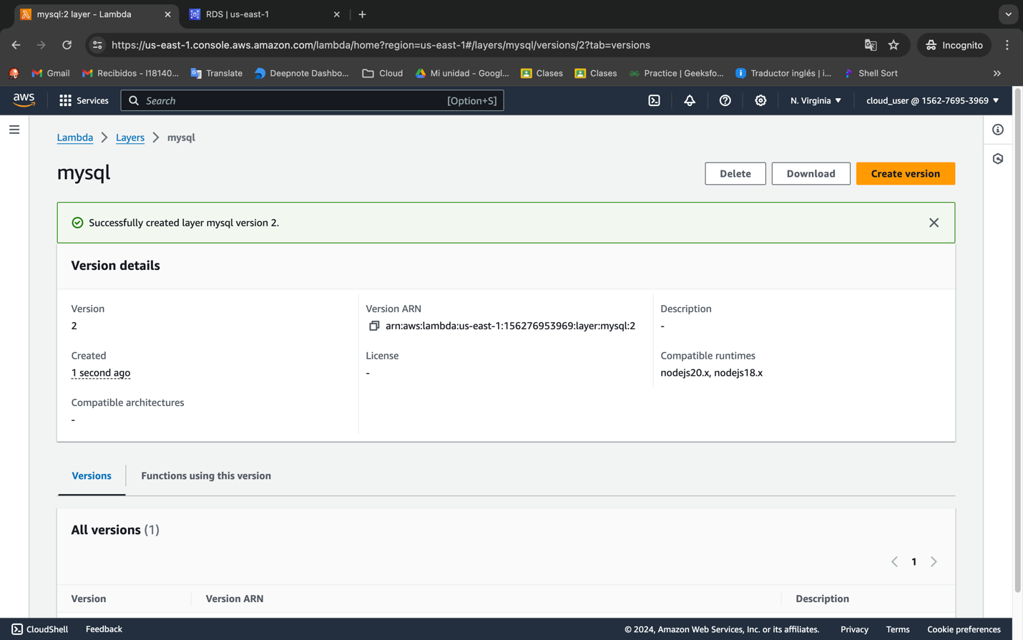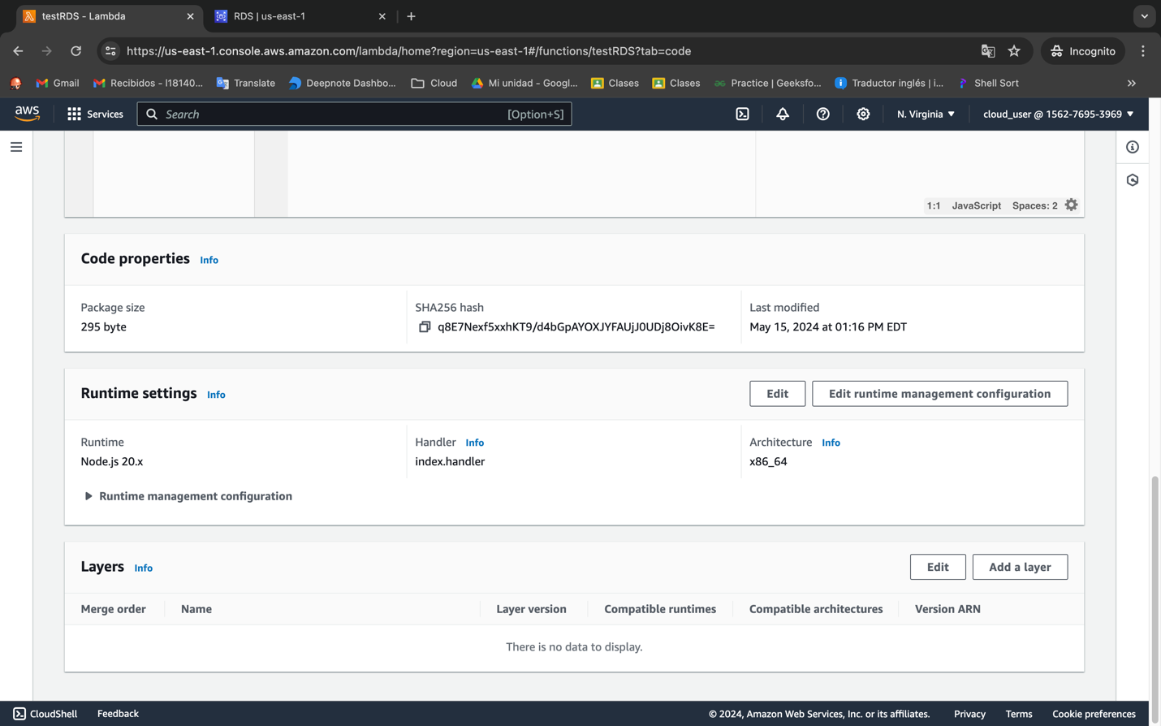

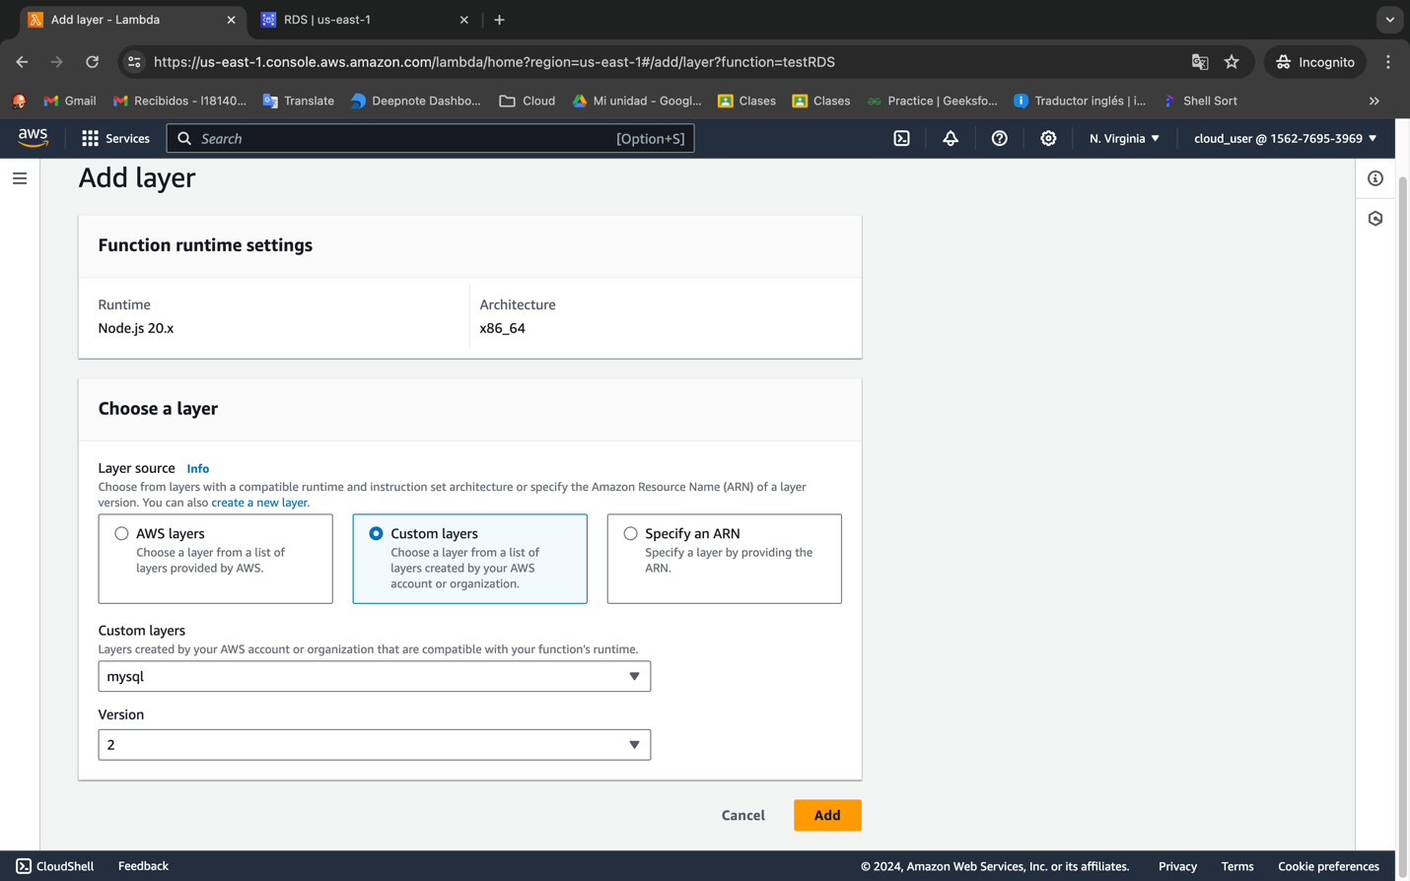

import mysql from 'mysql2/promise';

export const handler = async (event, context, callback) => {

try {

const connection = await mysql.createConnection({

host: "<RDS Endpoint>",

user: "username",

password: "password",

database: "example",

});

// Create 'pets' table

await connection.execute(`

CREATE TABLE IF NOT EXISTS pets (

id INT AUTO_INCREMENT PRIMARY KEY,

name VARCHAR(255) NOT NULL,

age INT NOT NULL

)

`);

console.log('Table created: pets');

// List all tables

const [rows] = await connection.execute('SHOW TABLES');

console.log('Tables:');

rows.forEach((row) => {

console.log(row[`Tables_in_example`]);

});

connection.end();

callback(null, {

statusCode: 200,

body: 'Tables listed successfully',

});

} catch (err) {

console.error(err);

callback(err, {

statusCode: 500,

body: 'Error listing tables',

});

}

};

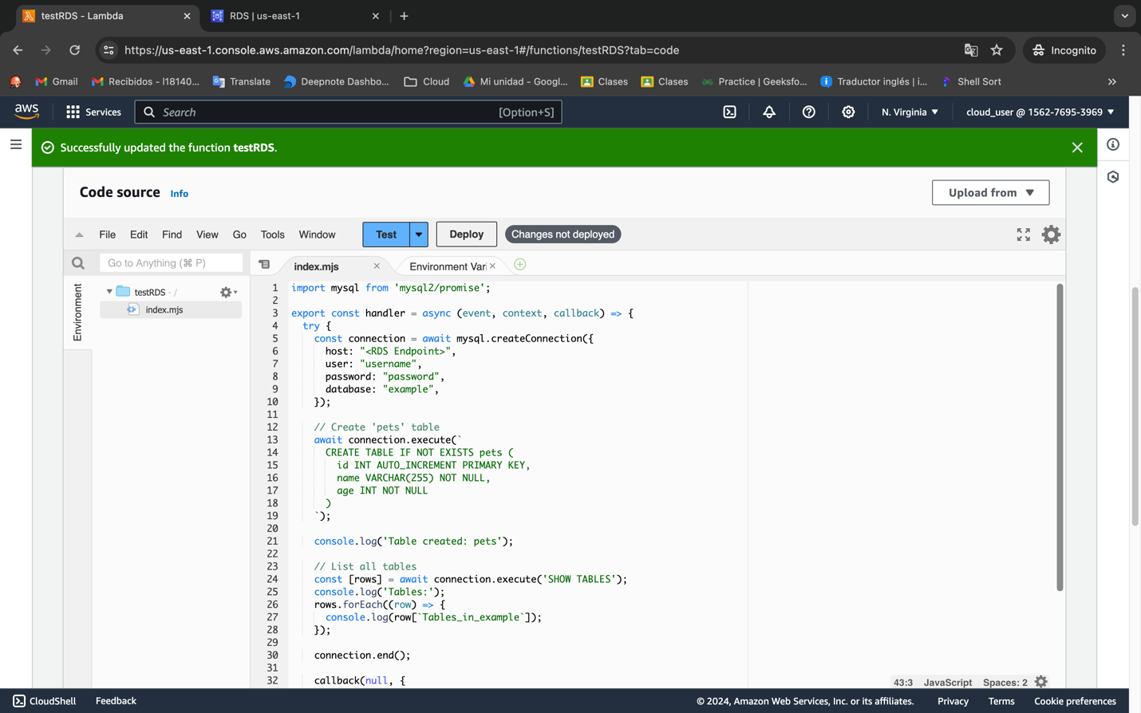

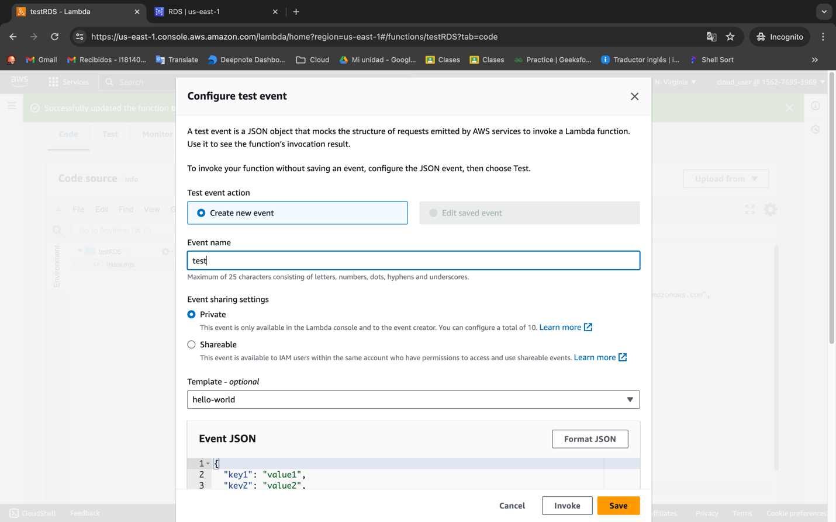

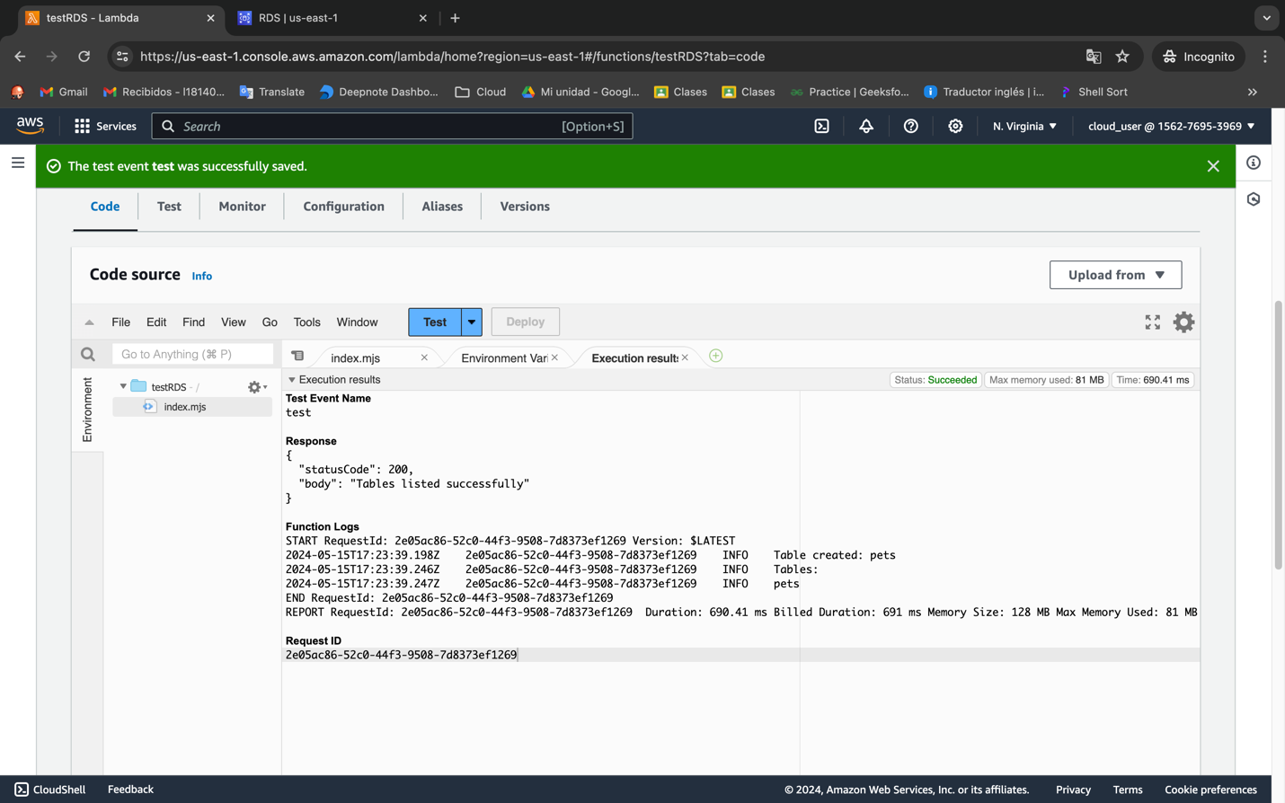

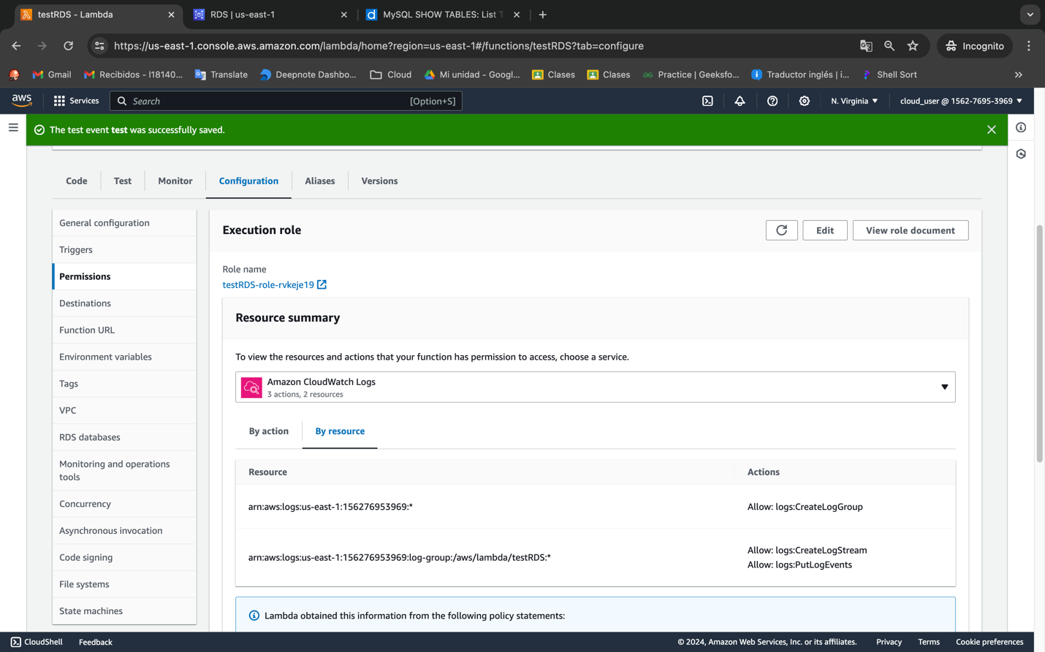

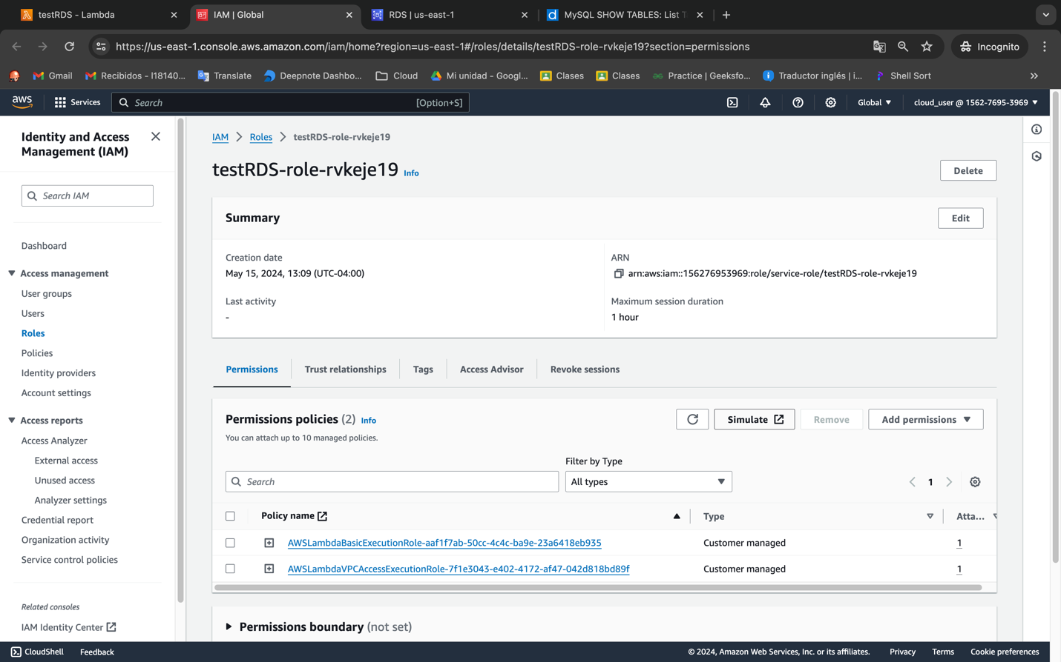

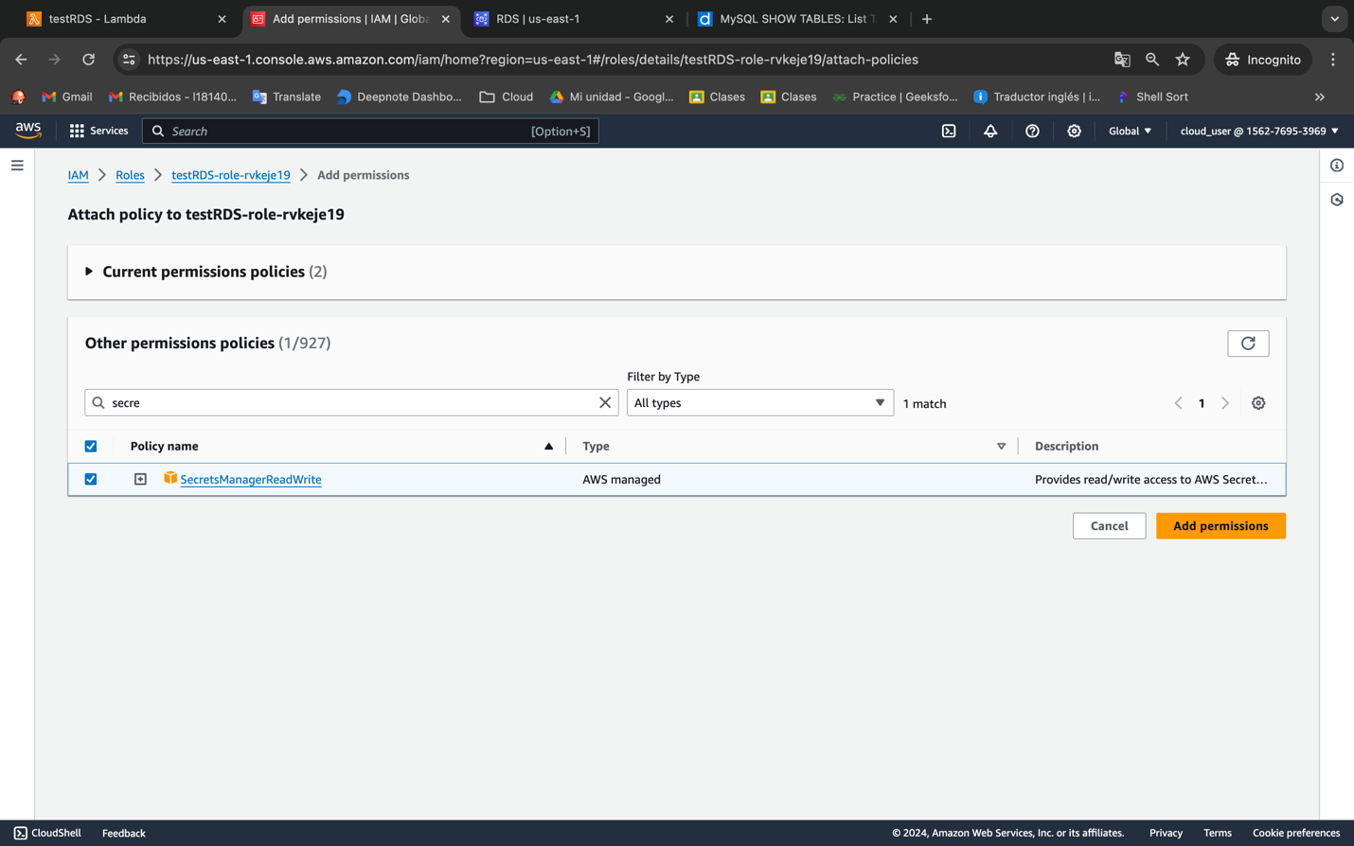

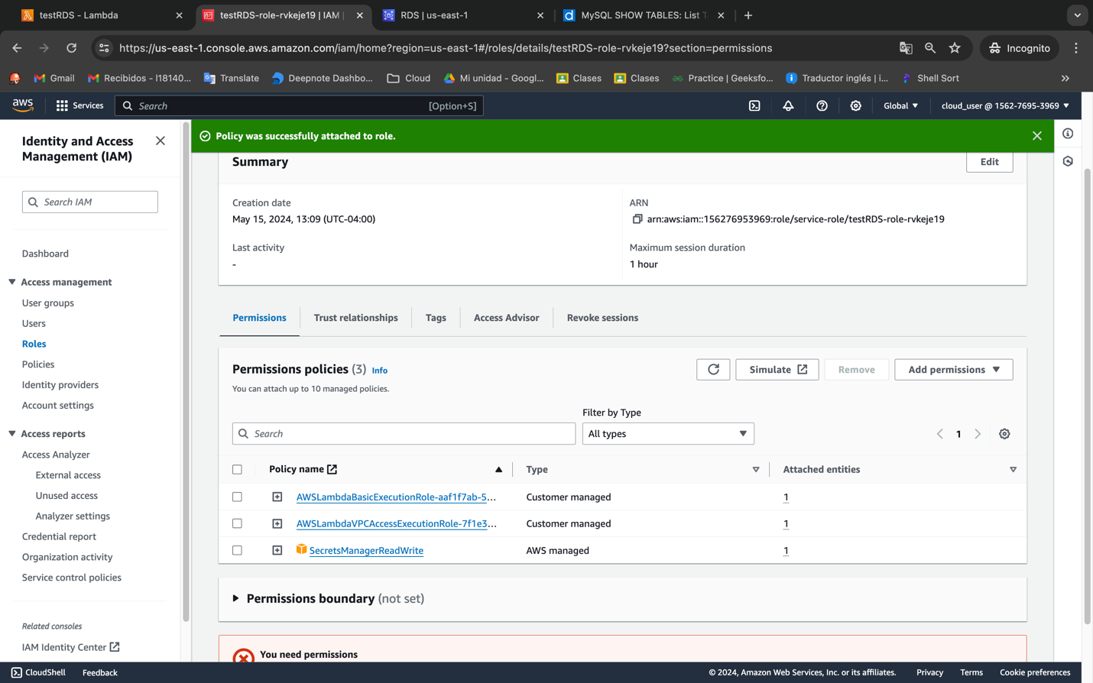

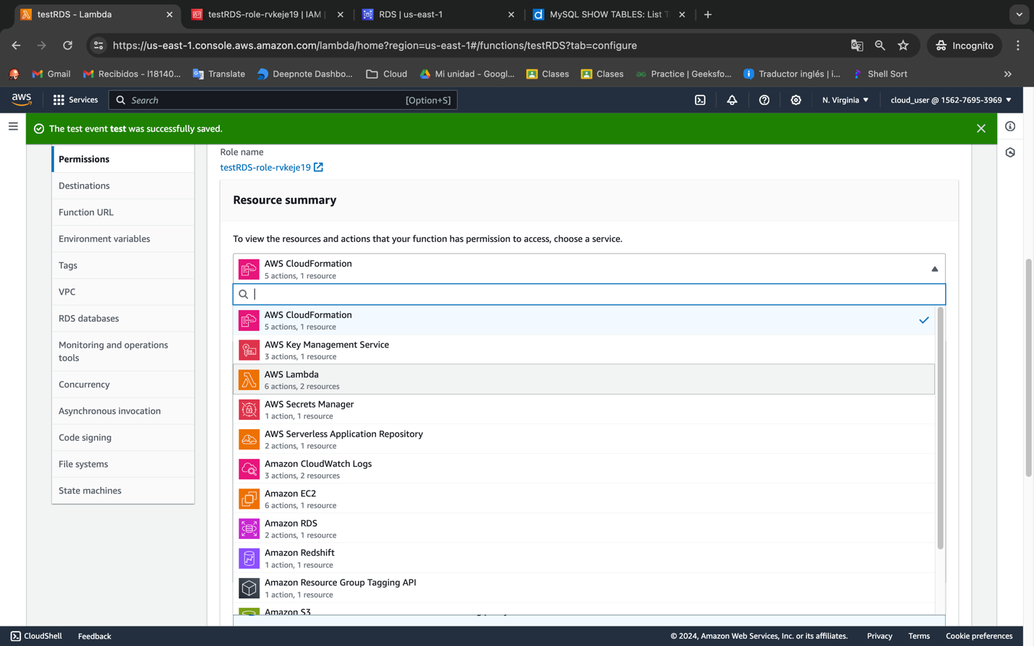

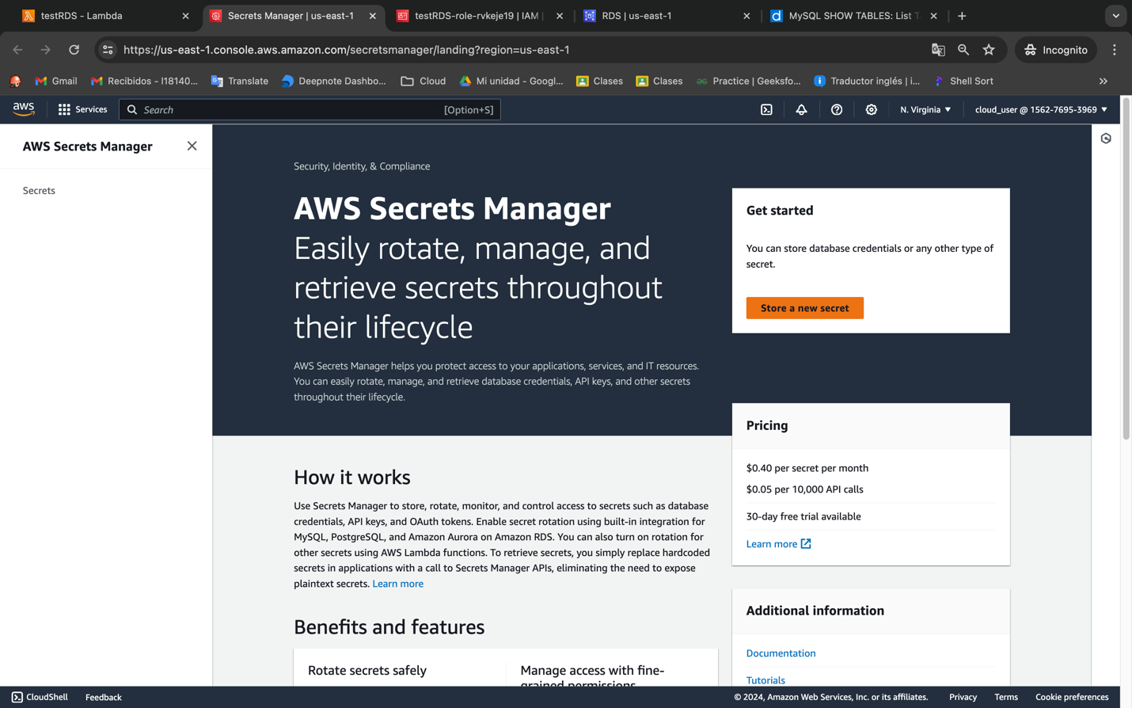

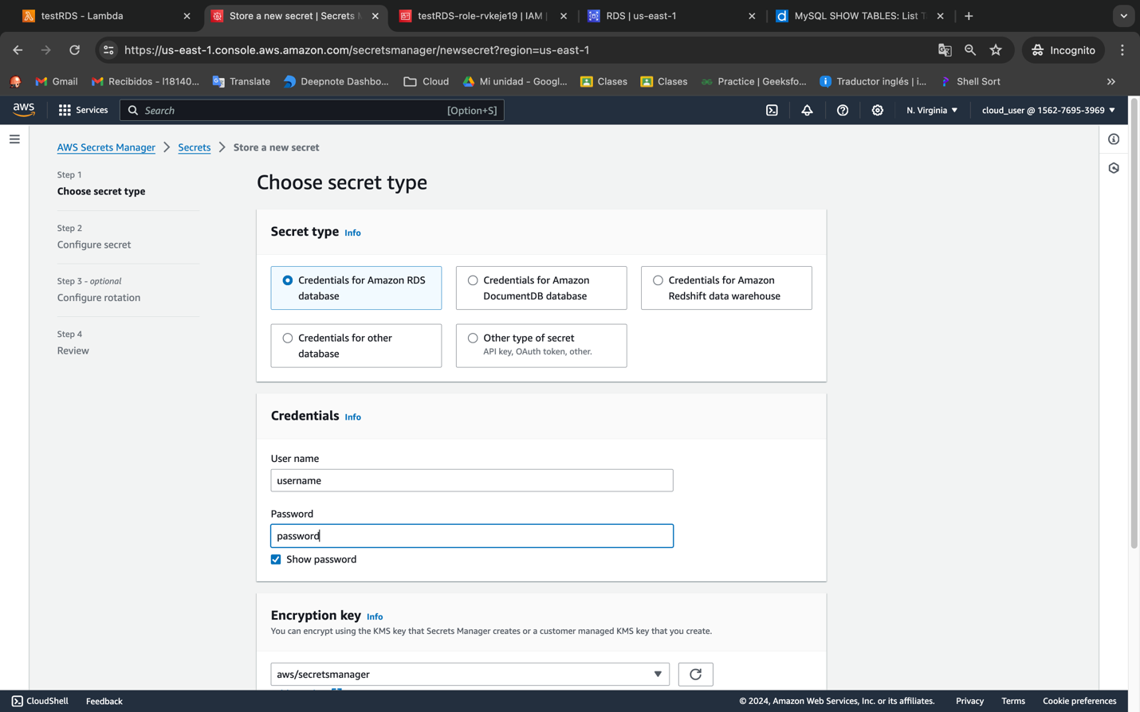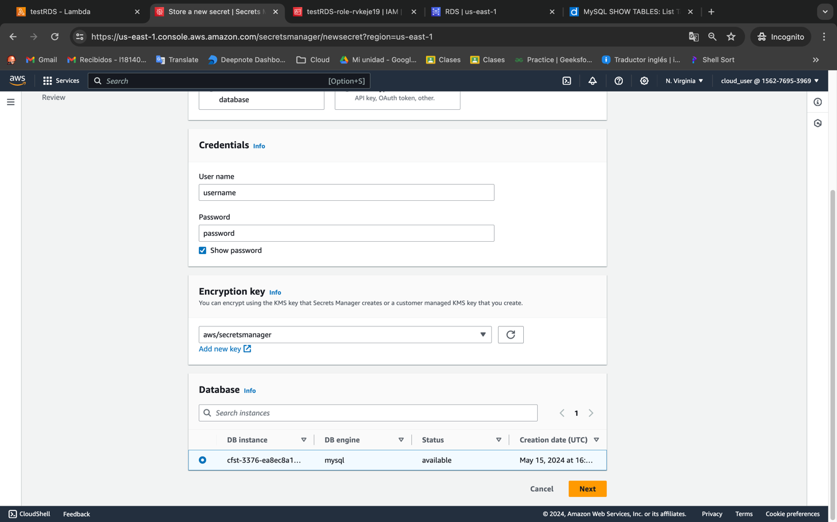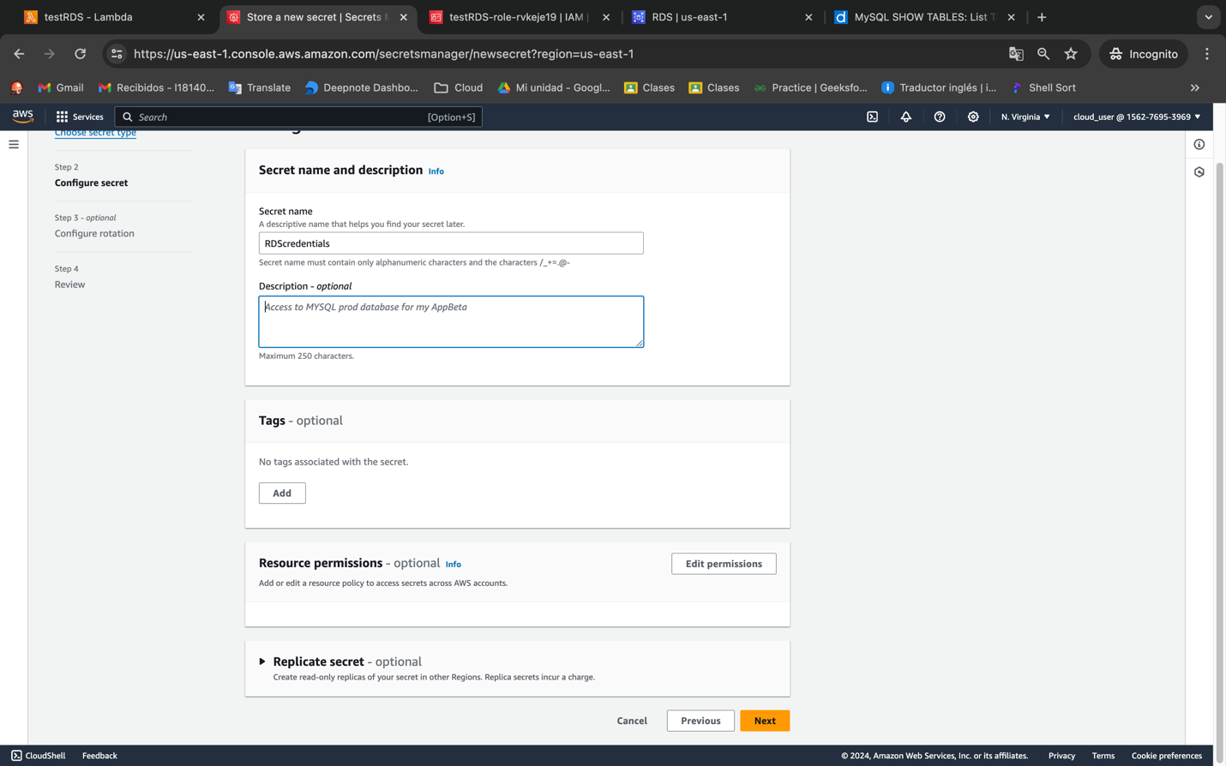

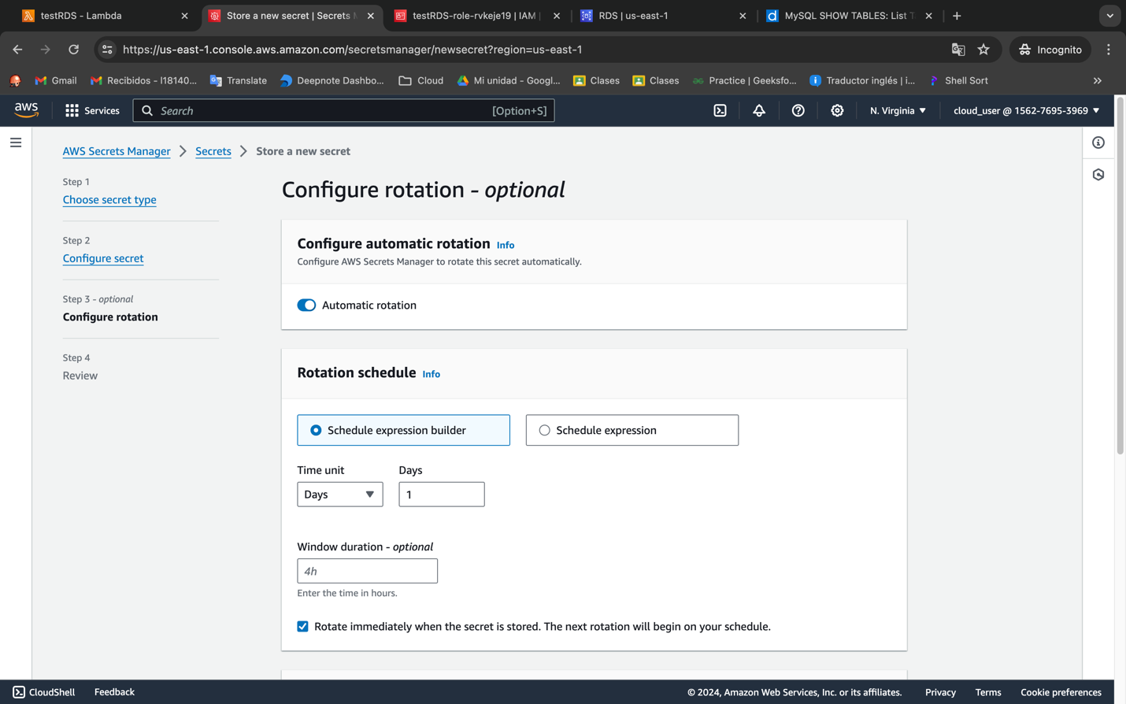

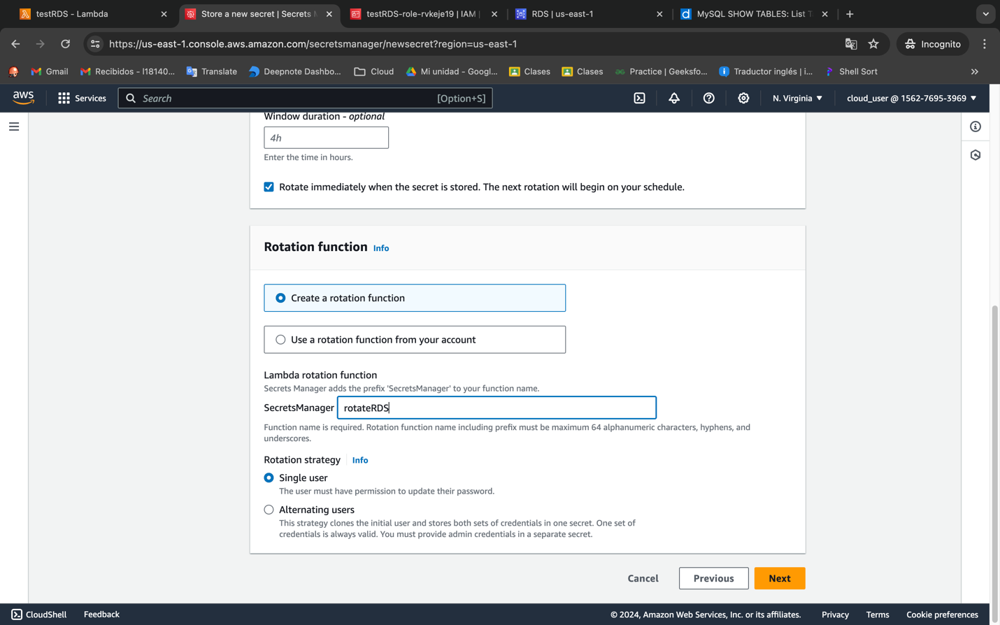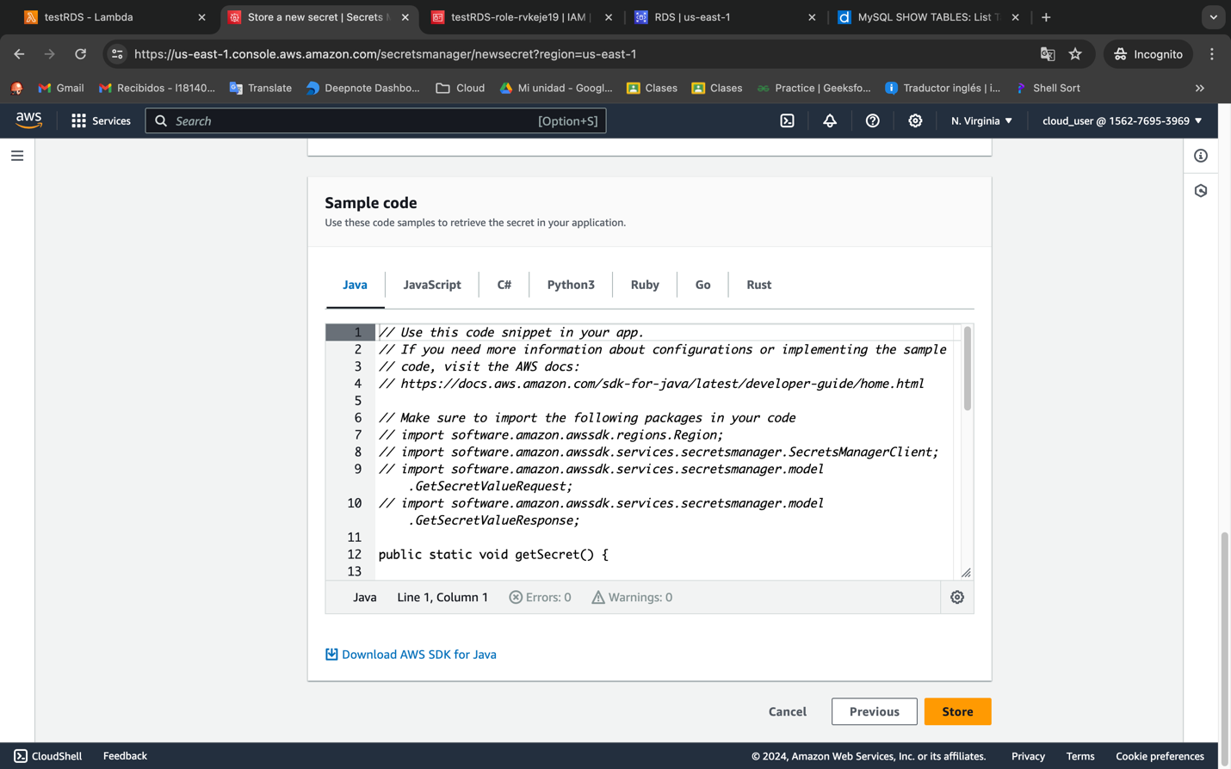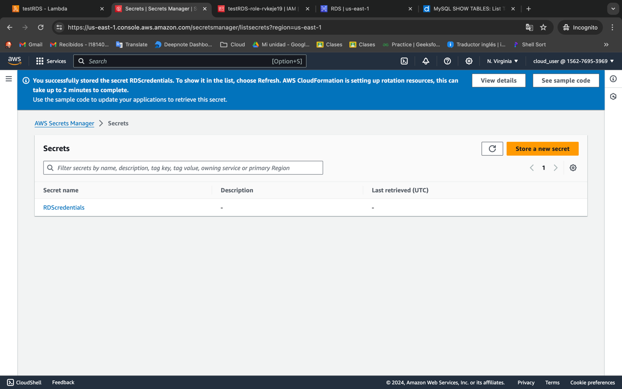

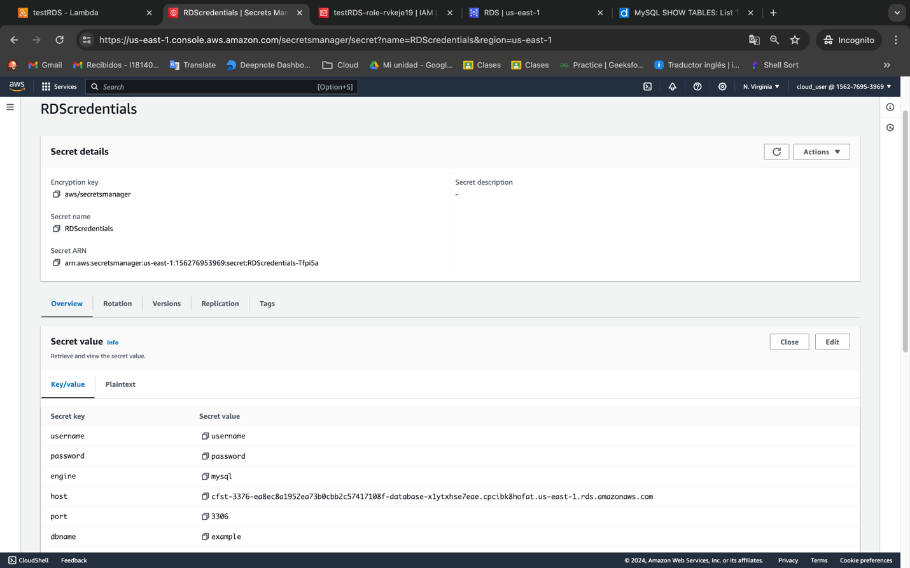

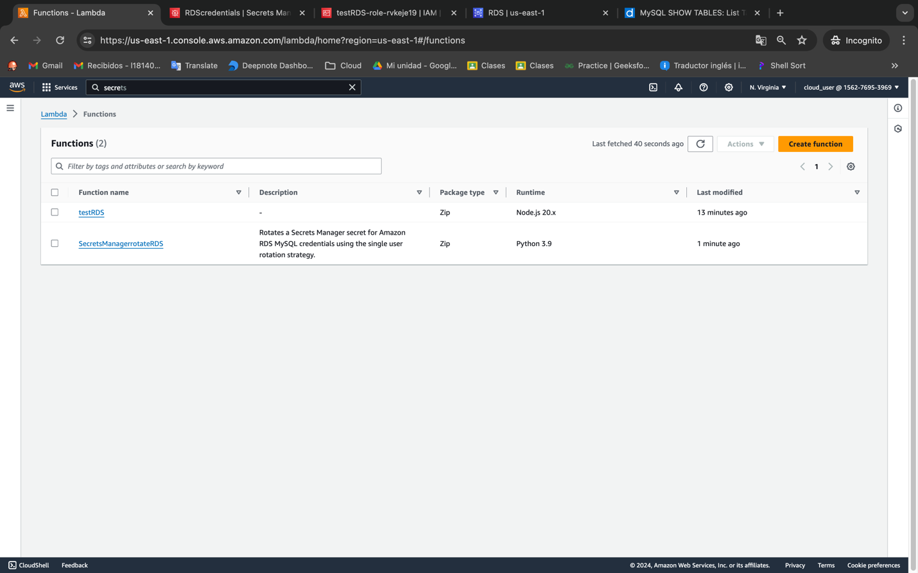

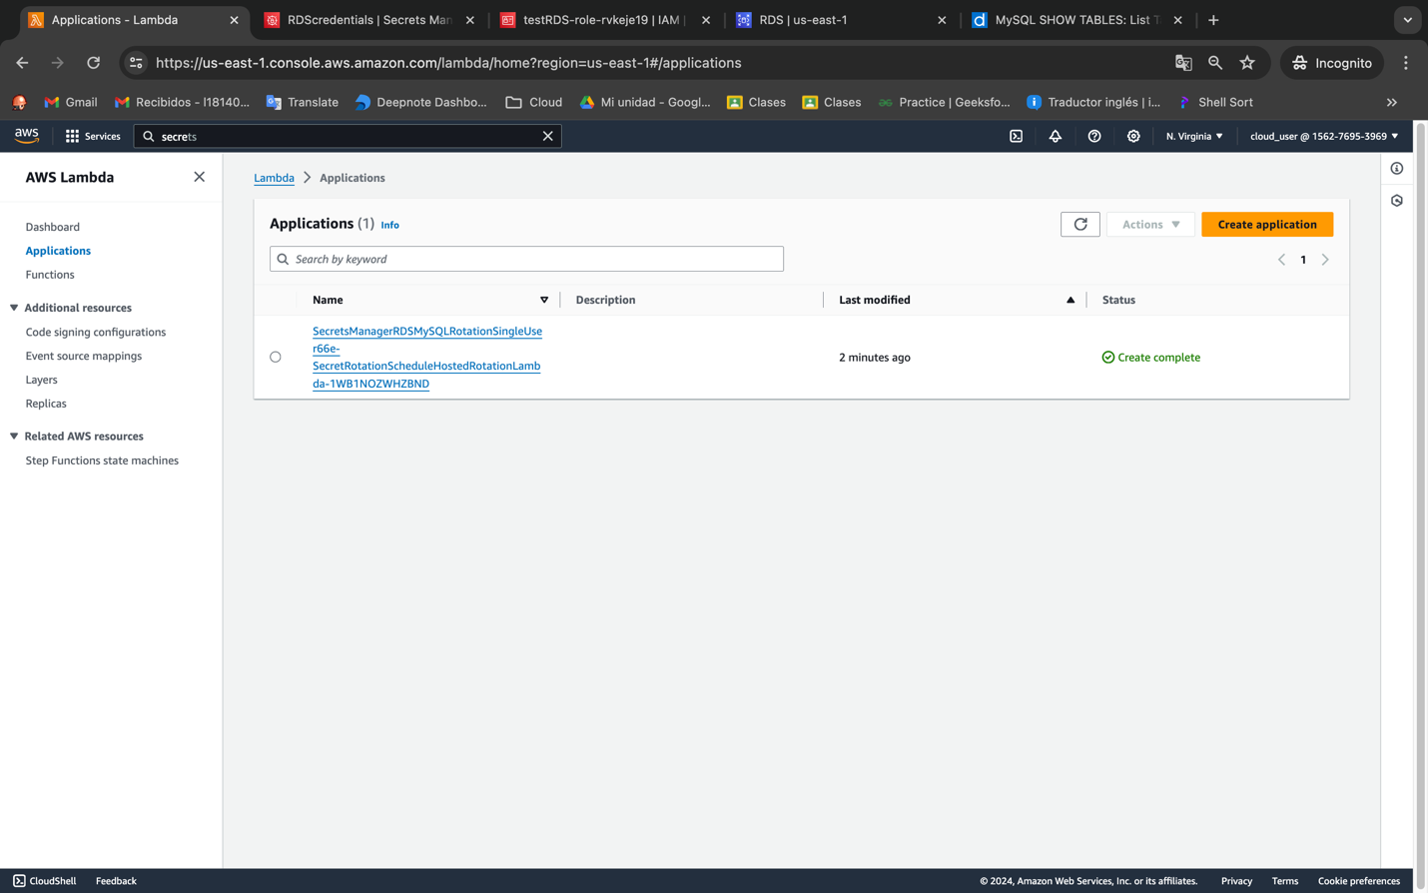

import mysql from 'mysql2/promise';

import AWS from 'aws-sdk';

const secretName = 'RDScredentials';

const region = 'us-east-1';

const rdsEndpoint = '<RDS Endpoint>';

const databaseName = 'example';

AWS.config.update({ region: region });

const secretsManager = new AWS.SecretsManager();

export const handler = async (event, context) => {

try {

const data = await secretsManager.getSecretValue({ SecretId: secretName }).promise();

const secret = JSON.parse(data.SecretString || Buffer.from(data.SecretBinary, 'base64').toString('ascii'));

const { username, password } = secret;

const connection = await mysql.createConnection({

host: rdsEndpoint,

user: username,

password: password,

database: databaseName,

});

const [rows] = await connection.execute('SHOW TABLES');

console.log('Tables:');

rows.forEach((row) => {

console.log(row[`Tables_in_${databaseName}`]);

});

connection.end();

return {

statusCode: 200,

body: 'Tables listed successfully',

};

} catch (err) {

console.error('Error:', err.message);

return {

statusCode: 500,

body: 'Error listing tables',

};

}

};

